**How to setup bioollect in Intellij**

1. Clone biocollect grails 3 project into a directory.

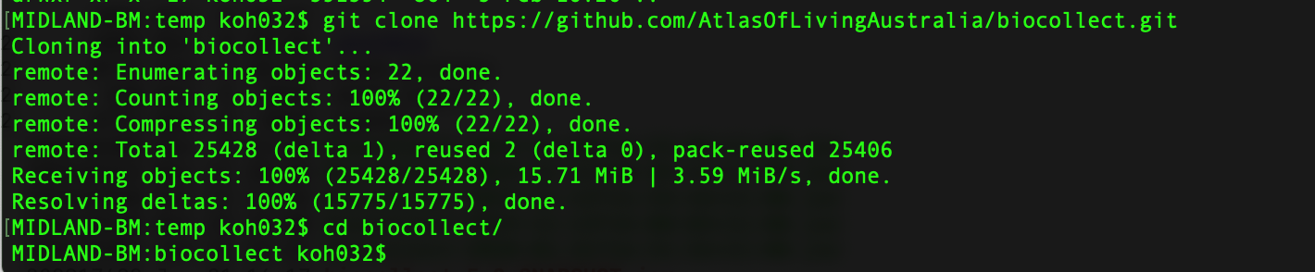

1. Checkout the branch which contain the latest grails3 code.

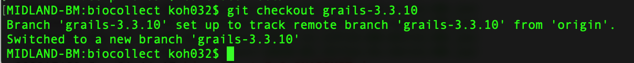

1. In Intellij, click Open and navigate to the biocollect folder then click on Open.

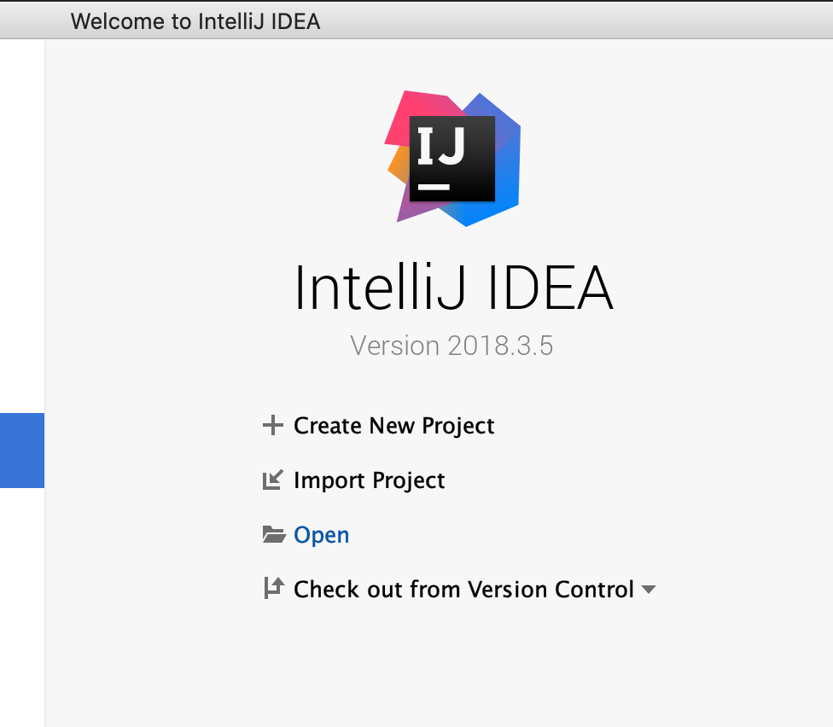

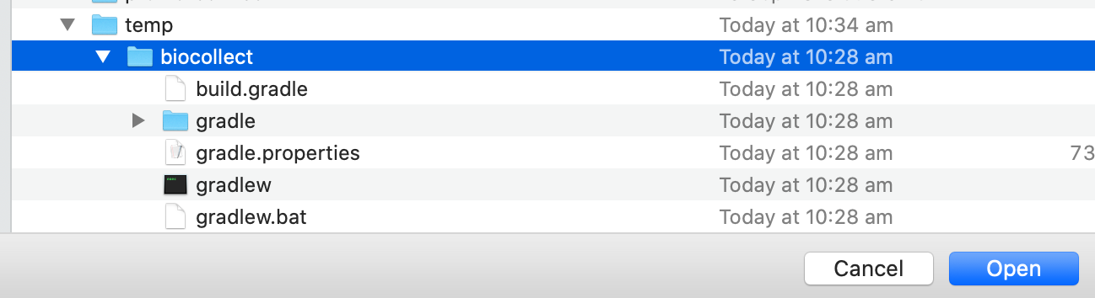

1. The first time when you open the project, you need to Import Project from Gradle. As the biocollect project comes with Gradle wrapper, keep the default setting and click OK.

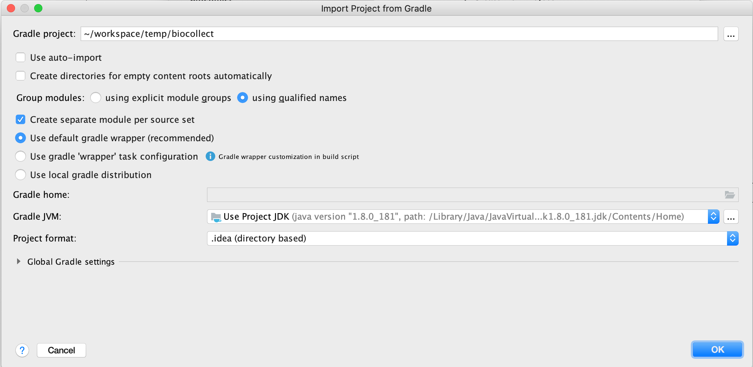

1. Once the project opens, wait for Intellij to configure the build. You should see the following.

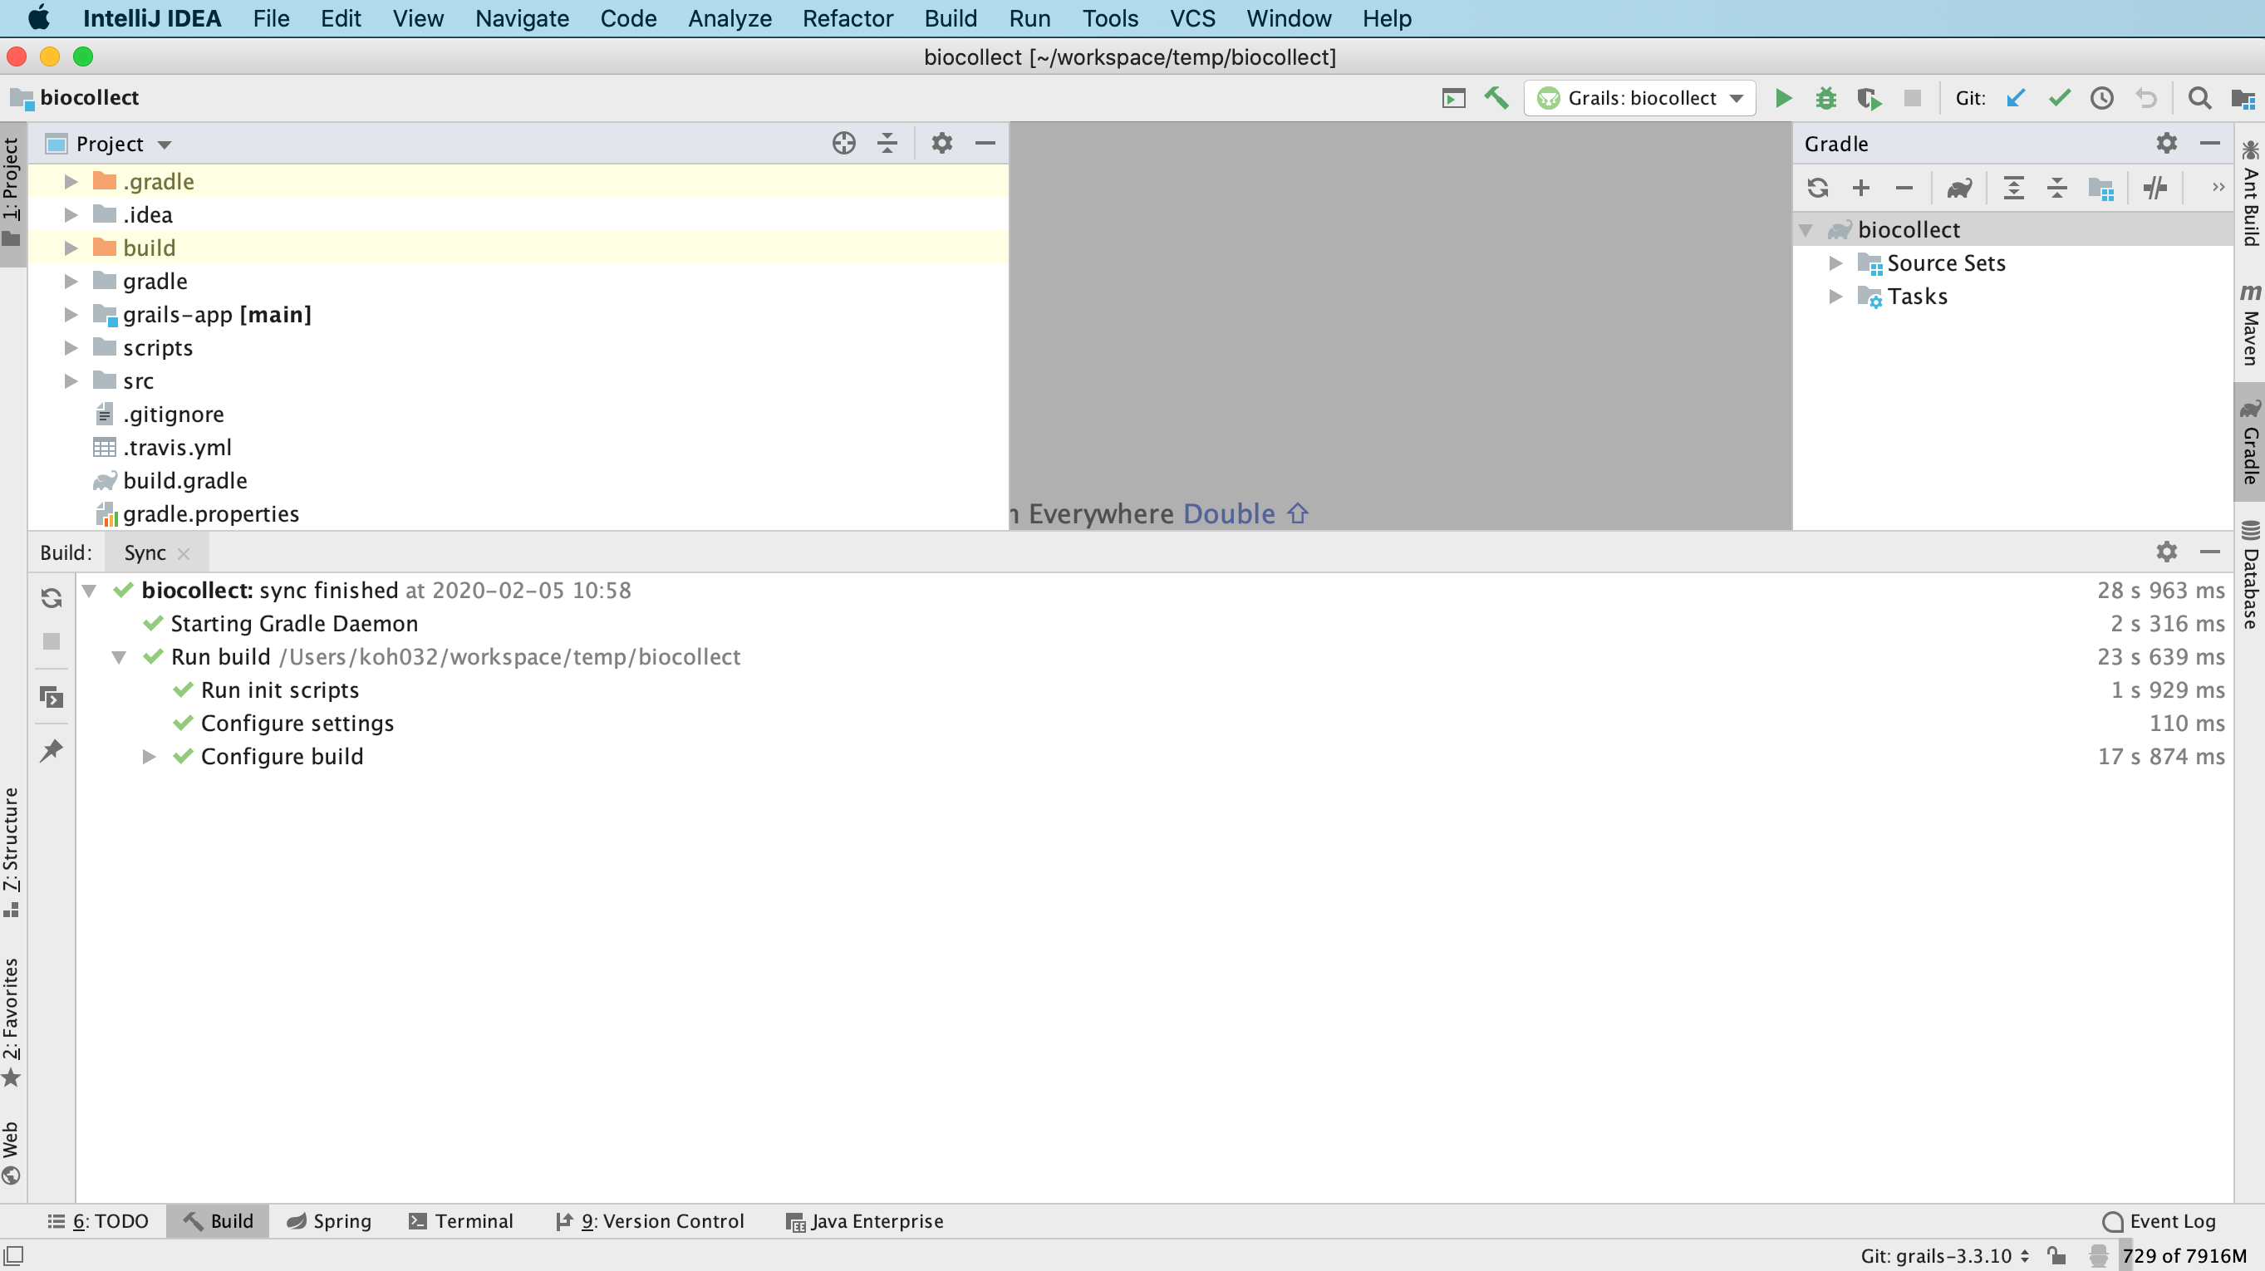

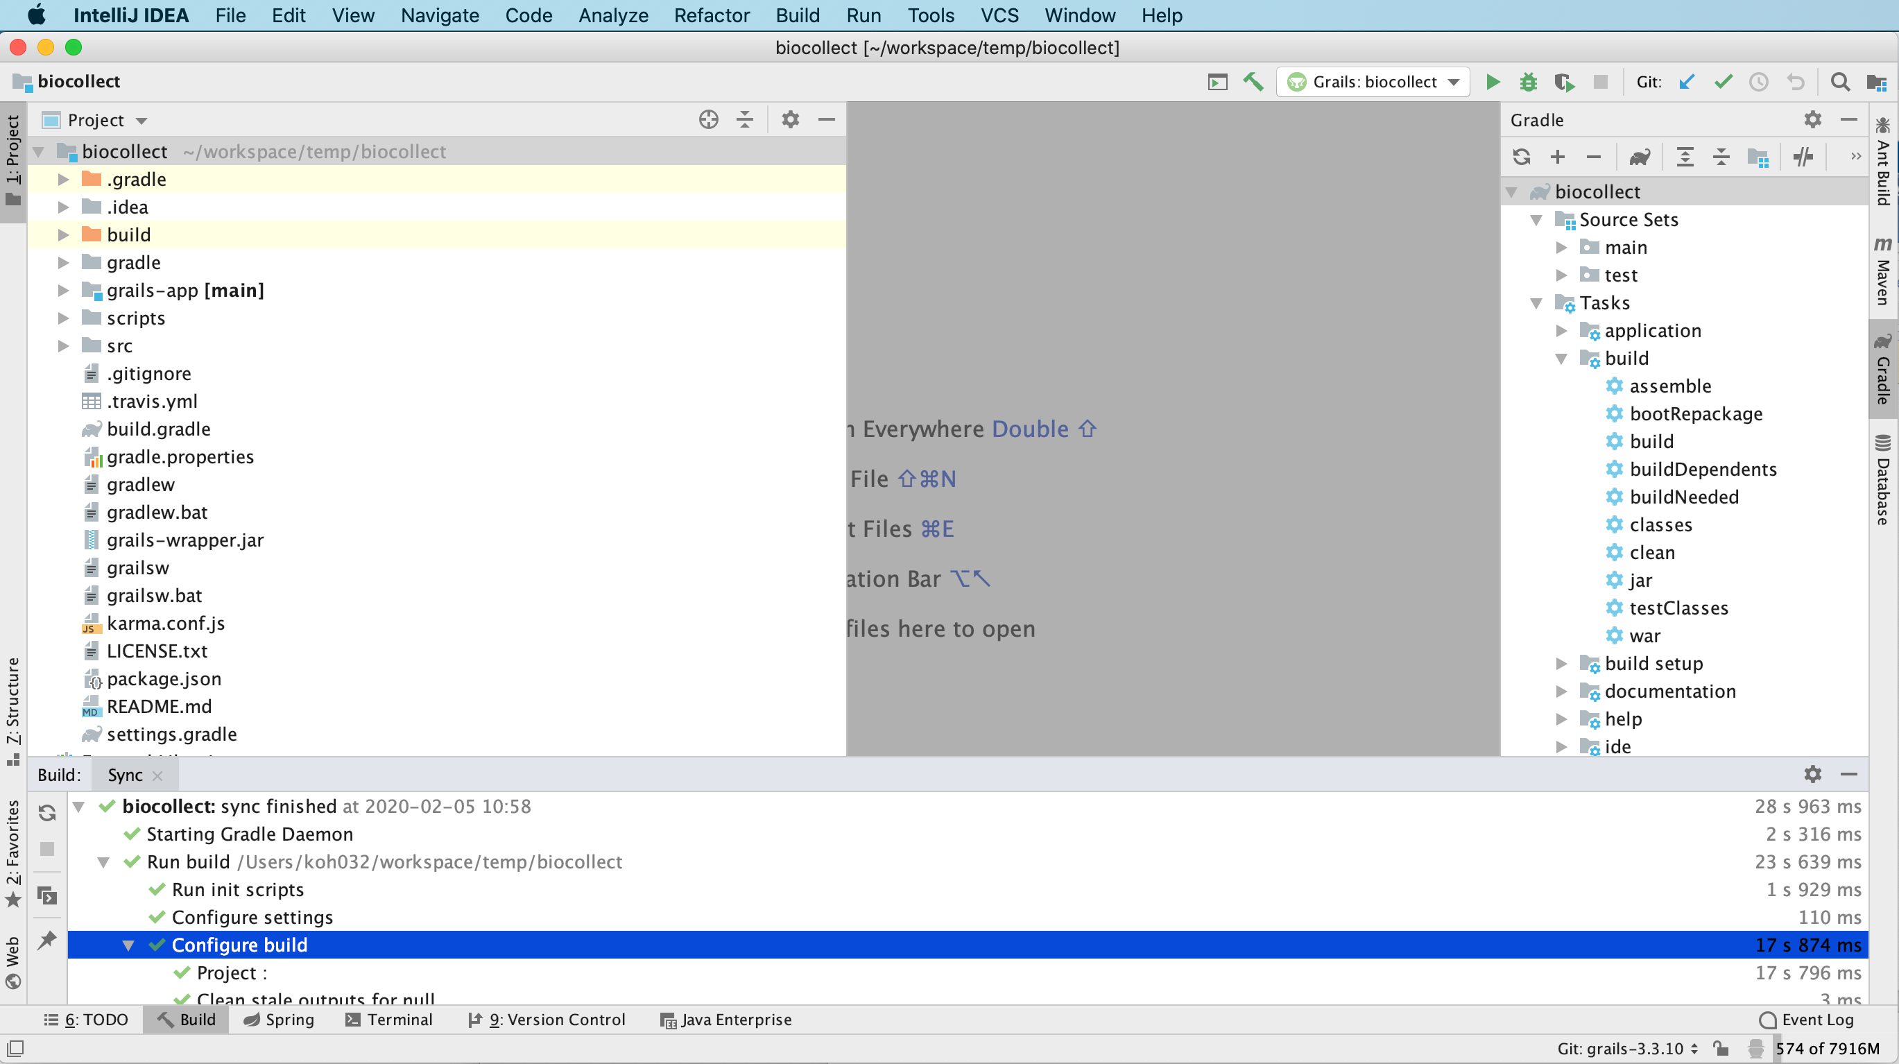

1. Before running biocollect grails 3, make sure that the following properties file exist in /data/biocollect/config/biocollect-config-grails3.properties

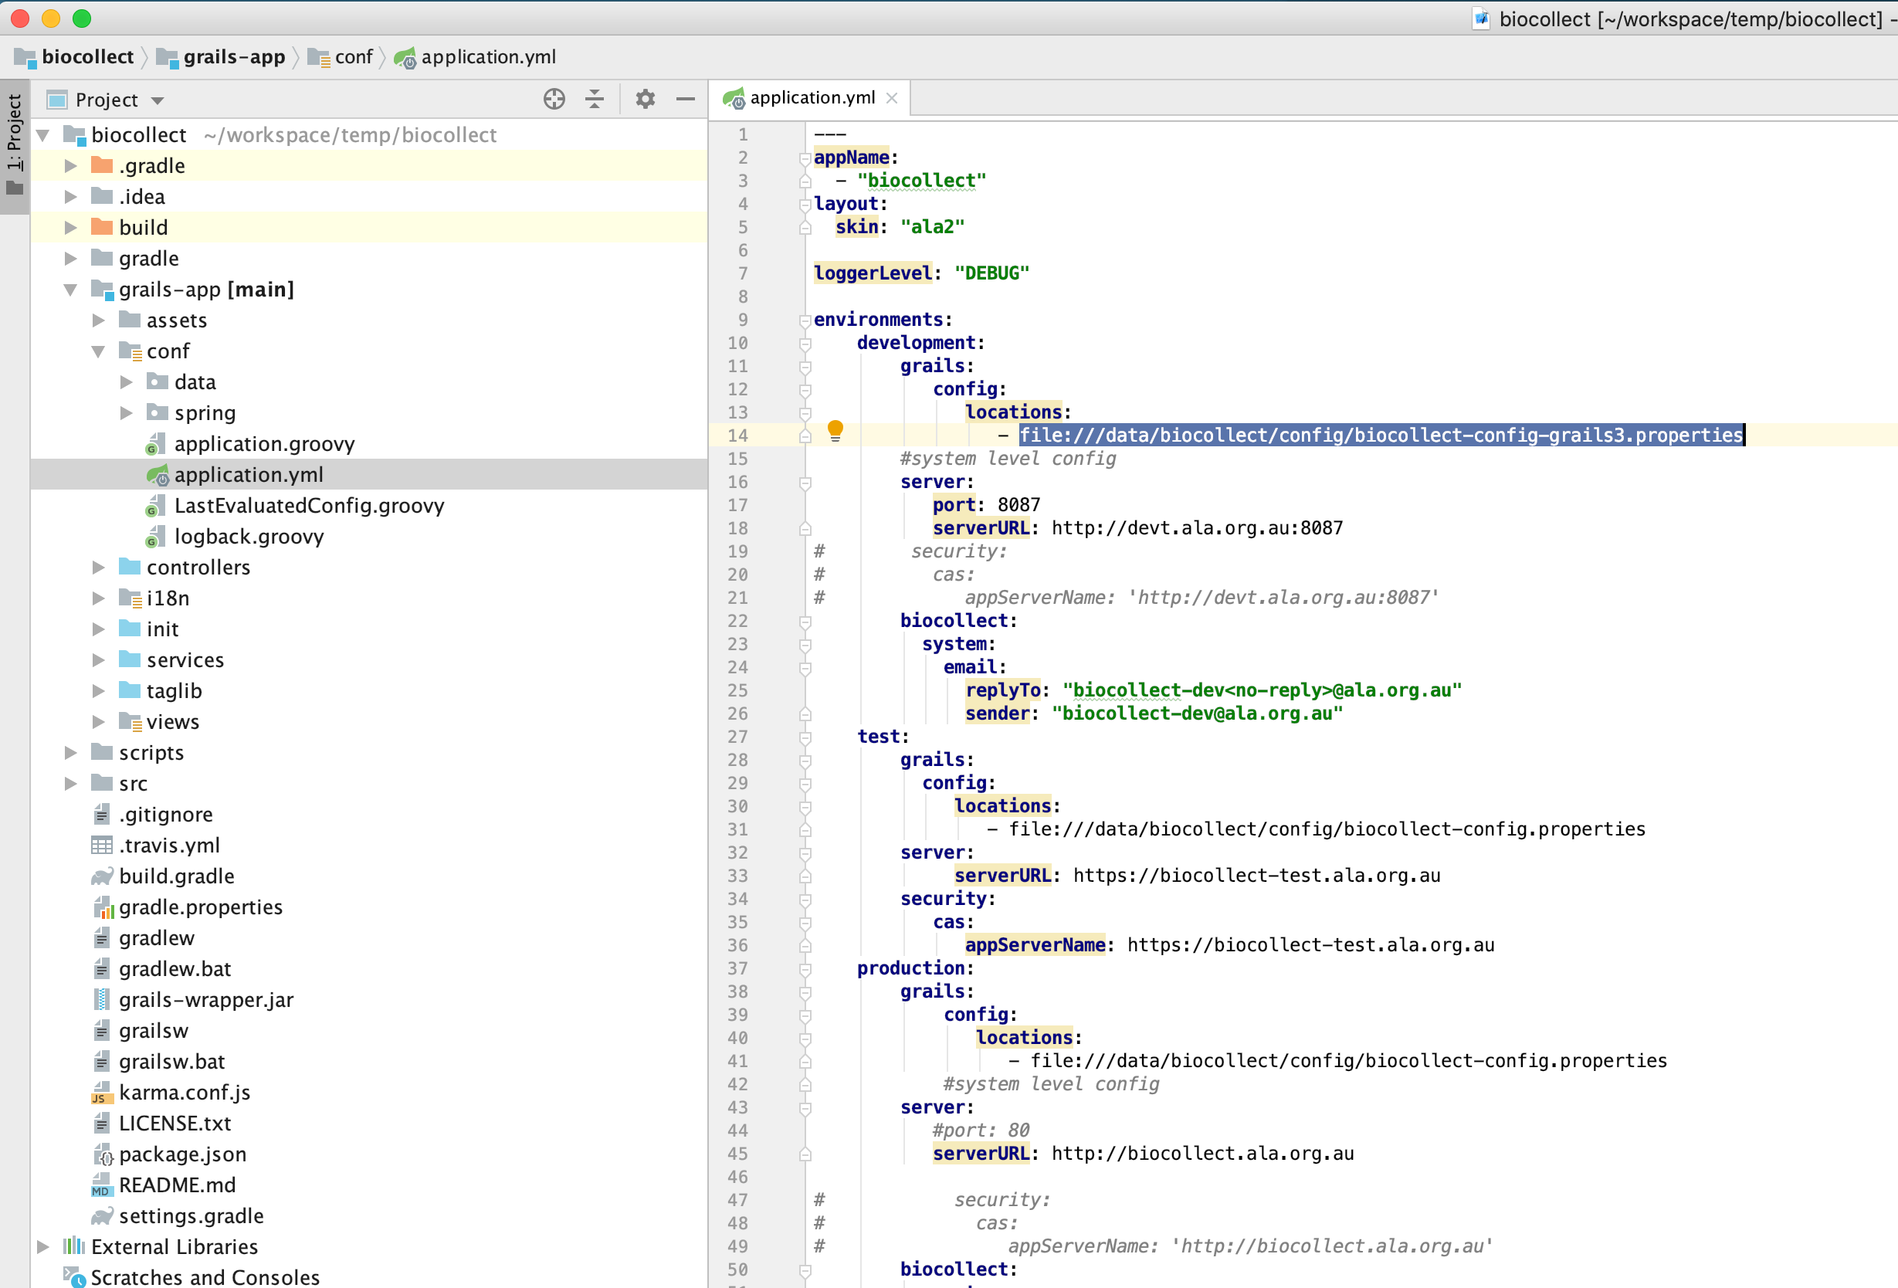

The minimum config in the properties file looks like this:

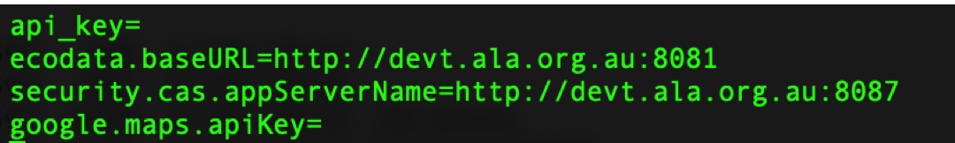

**How to modify plugins in a grails 3 project**

1. To modify a plugin project for biocollect, for eg: ala-map-plugin, first git clone ala-map-plugin in the same folder where biocollect is. Checkout branch grailss3.

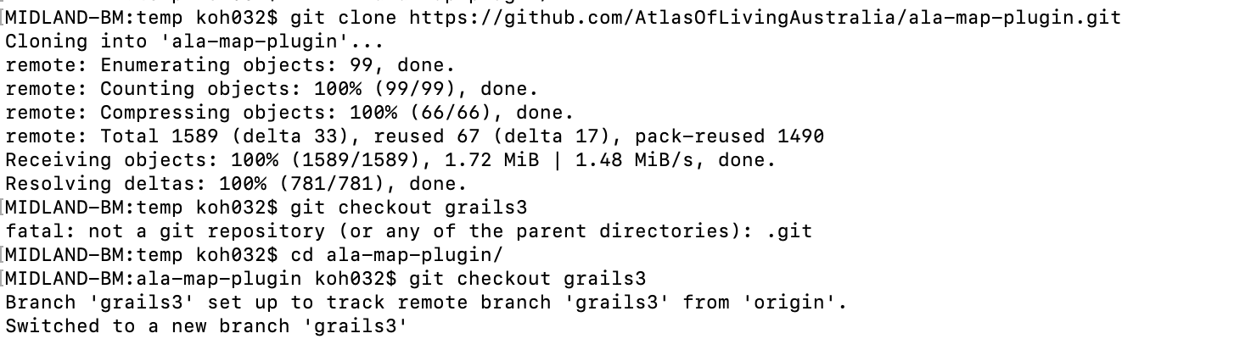

1. In biocollect project, modify settings.gradle and add the following:

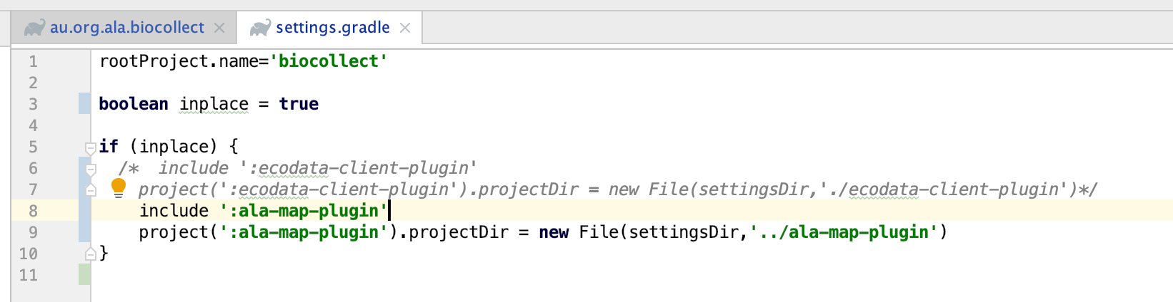

1. In biocollect project, modify the build.gradle file to set inplace = true, then add the inplace plugin

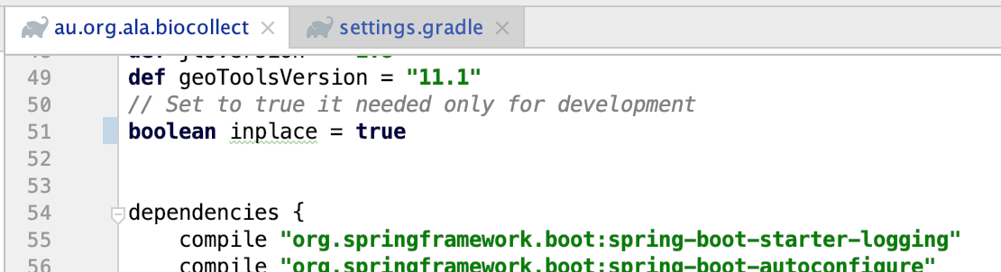

Make sure dependencies does not include the ala-map-plugin as we have inplace plugin project which is part of the build.

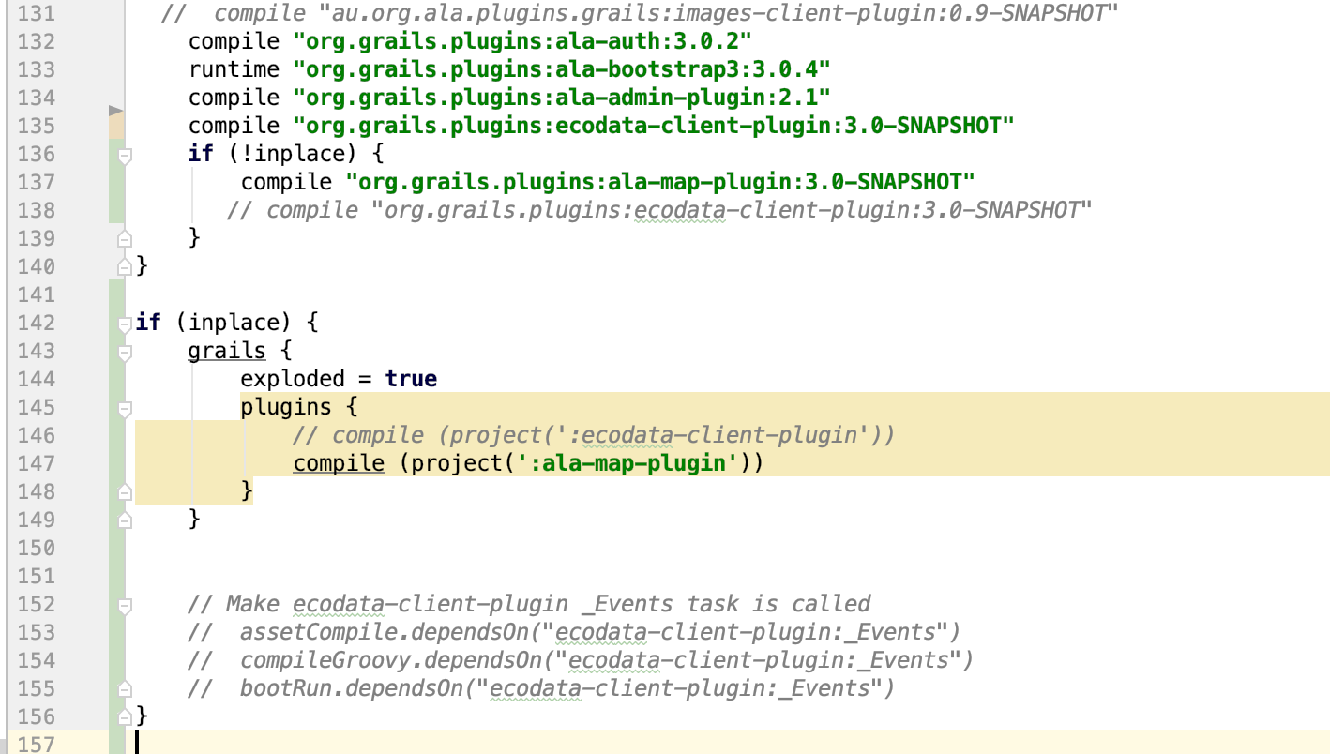

1. Once the build.gradle is modified, rebuild biocollect project. Once the project has a successful build, you should now see ala-map-plugin project as well.

